

**Excel Assignment - 10**

1. See the below picture and create the exact table with exact formatting. Font – ‘Times New Roman’ Size – 14, Color of first line Orange.

| **Roll**  **No.** | **Name of the student** | **Sub-1** | **Sub-2** | **Sub-3** | **Sub-4** | **Sub-5** | **Sub-6** |
| --- | --- | --- | --- | --- | --- | --- | --- |
| 100101 | Rohan | 72 | 55 | 52 | 69 | 95 | 32 |
| 100102 | Mohan | 65 | 51 | 63 | 85 | 71 | 69 |
| 100103 | Ravi | 72 | 56 | 78 | 85 | 47 | 68 |
| 100104 | Ruby | 68 | 71 | 85 | 84 | 78 | 60 |
| 100105 | Radhika | 80 | 78 | 58 | 65 | 68 | 45 |
| 100106 | Rakhi | 61 | 78 | 45 | 62 | 75 | 64 |
| 100107 | David | 78 | 69 | 96 | 52 | 63 | 87 |
| 100108 | Monika | 96 | 85 | 86 | 84 | 45 | 63 |
| 100109 | Tommy | 75 | 63 | 54 | 63 | 61 | 98 |
| 100110 | Rakesh | 63 | 52 | 96 | 87 | 78 | 45 |

Answer: 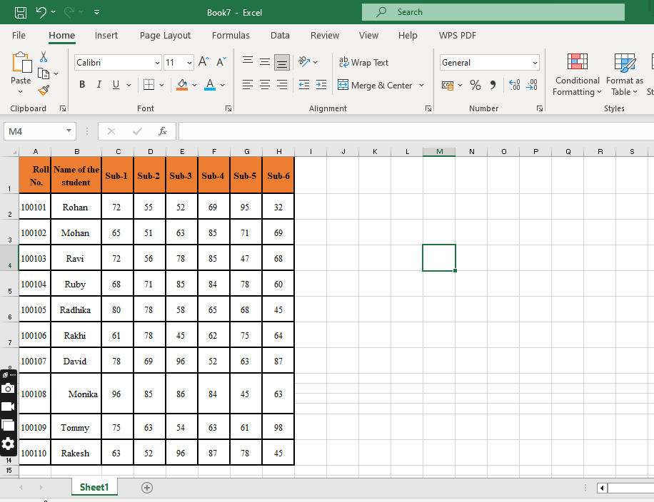

2. From the above table use Sum Formula and find the total for each student.

Answer: 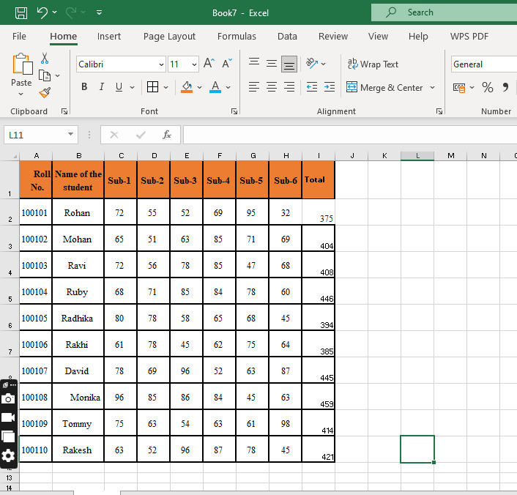

3. Calculate Average for each student in the next row. UseFormulas.

Answer: 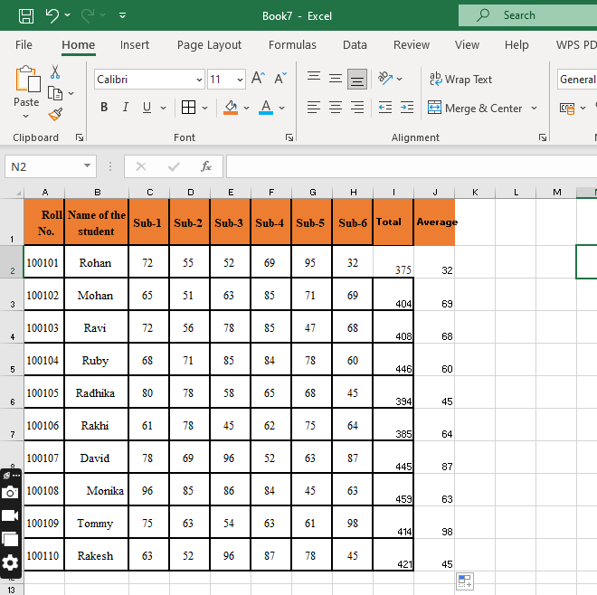

4. Calculate Rank for each student. Use Formulas.

Answer: 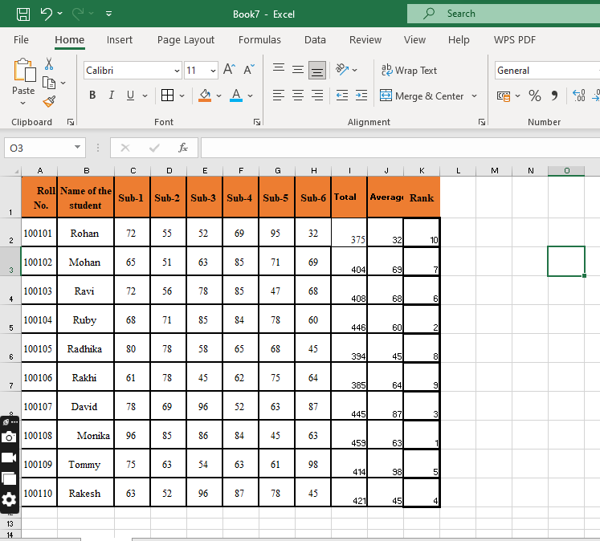

5. Calculate Percentage for each student. Use Formulas. Round off the decimals up to 2 points.

Answer: 